Planning Commission Hearing / ZTA #20-156
11/2/2020
My Name is Wayne Luckel, I Live at 8445 Fairground Road in Laplata, Maryland 20646. I am Not opposed to Agritourism as I have helped both the county and the Charles County Fairgrounds) in the past. What I mean by this is I used to cut the county easements, pick up trash weekly and was one of three neighbors that agreed to shut down the short road that leads directly into the fairgrounds so they could usher buses of people into the fairgrounds for the (Fair) and also for first responders to park and get people out in case of an emergency. I signed a piece of paper agreeing to this from the Charles county sheriff’s office as I was approached by one of their officers. I am the only resident on the right side leading into the Fairgrounds. But as you progress in your endeavors in (Agri-tourism related land uses) please consider protections for (Residential Residents in Zoning). The Charles County Fair inc which is a privately owned (Non –Profit Commercial Entity) Bought a Residential Lot Directly Behind Me which is Plat 19, Folio 88 lot 2 of the Charles county, Maryland Land Records. This is identified as (Fair Heights Village a Minor Subdivision), I am Lot 3. The Fairgrounds Timbered Lot 2, well basically they (Clear Cut Lot 2), this is not what was agreed to verbally. I was told by Fairgrounds President @ the time that they wanted to take some mature trees out of lot 2 and would like to come within 5 feet from my property line. I asked what does the county want, he said 25 feet. I said where do you want to come within 5 feet of my property line, he said I don’t know where. I said okay lets take a look. I told him that he could only come within 5 feet of my property line only to the two trees he showed me with blue dots on them and that was basically right in front of the fairgrounds. I signed a piece of paper to what I thought we agreed to verbally as I have worked with the fairgrounds and the county in the past. Instead, they timbered within 5- feet the total length of my property line which is approximately an eighth of a mile, they also took out the states 75-foot tree buffer. I tried calling the Charles County Government to intervene, they did nothing. It’s to My understanding that the Fairgrounds want to make this a 5 acre (Grass parking lot). This will Adversely Affect my property Value. They Seem to have events going on every weekend prior to the pandemic. Wineries, Festivals Etc. I’m already dealing with Noise, trees falling from the Storm water run-off from the hill directly behind my house from the timbering. A File (CR02359) was created on this Timbering permit among other things on 1/17/2017 by (Carol A. Desoto) Senior Commissioner Specialist and Emailed to the Appropriate Staff. My house and septic system are not located as shown on the (plat). They are only (proposals). My house is set closer to the rear property line and my septic tank is located on the left rear (corner) of my house. The septic field runs out the left side and rear of my house. I’m concerned if they put a (grass parking lot) in that it will fill up my ground water and overflow my septic. Also, the (Contamination) of my Well From the oils and antifreeze from vehicles etc and me dealing with trash, smells, dust and people crossing in my woods to get to the Fairgrounds. Also, a fire which I’ve already had to deal with. There was a Report filed on this fire from the (Environmental) side of the health Department. I feel That Fire On 8/23/2018 was very (Dangerous) and was a Threat Targeted Towards my family and me!! Also, the Threatening phone calls I have received!! I can’t begin to tell you the Mental pain and suffering I have endured through this ongoing situation since 11-18-2016. I have been down to the Charles County Government building so many times in the past that I have lost count. Yet nobody wants to take any Accountability for the damage that’s been done to me or my property, whether it’s the County or the Fairgrounds!! Three minutes will not allow enough time for me to address every Situation that I have gone through, there’s so much more to this story. (I’m asking the planning commission to take a hard look at this). I have all the Factual Documents to include the Plat, Illegal Timbering Permit, Deed and Pictures from the Timbering Permit & Fire that are Attached to this Document.
Best Regards,
Wayne Luckel
This is Lot 2 of plat 19, folio 88 of the Charles County, Maryland Land Records. (also known as 8495 Crain highway Laplata, Maryland) A Residential Lot That is part of a minor subdivision called (Fair Heights Village) that the Charles county fairgrounds bought which is map 0055 grid 0007 parcel 0157 of Maryland Department of Assessments and taxation (Real Property Search). Keep Scrolling Down.
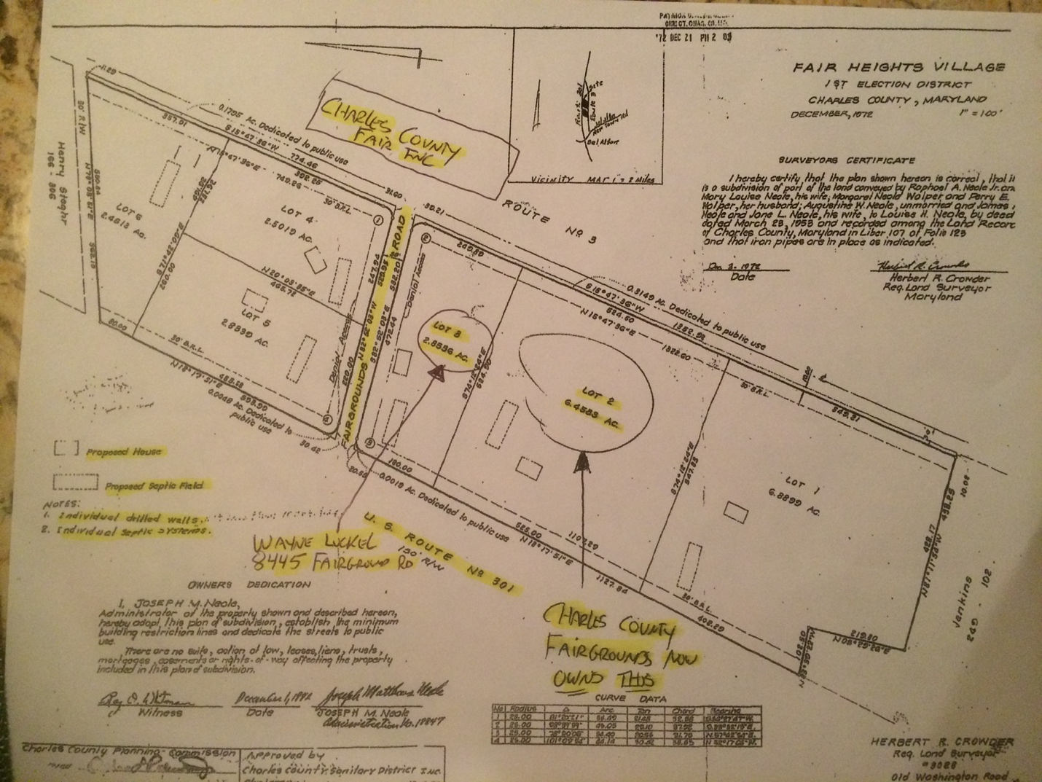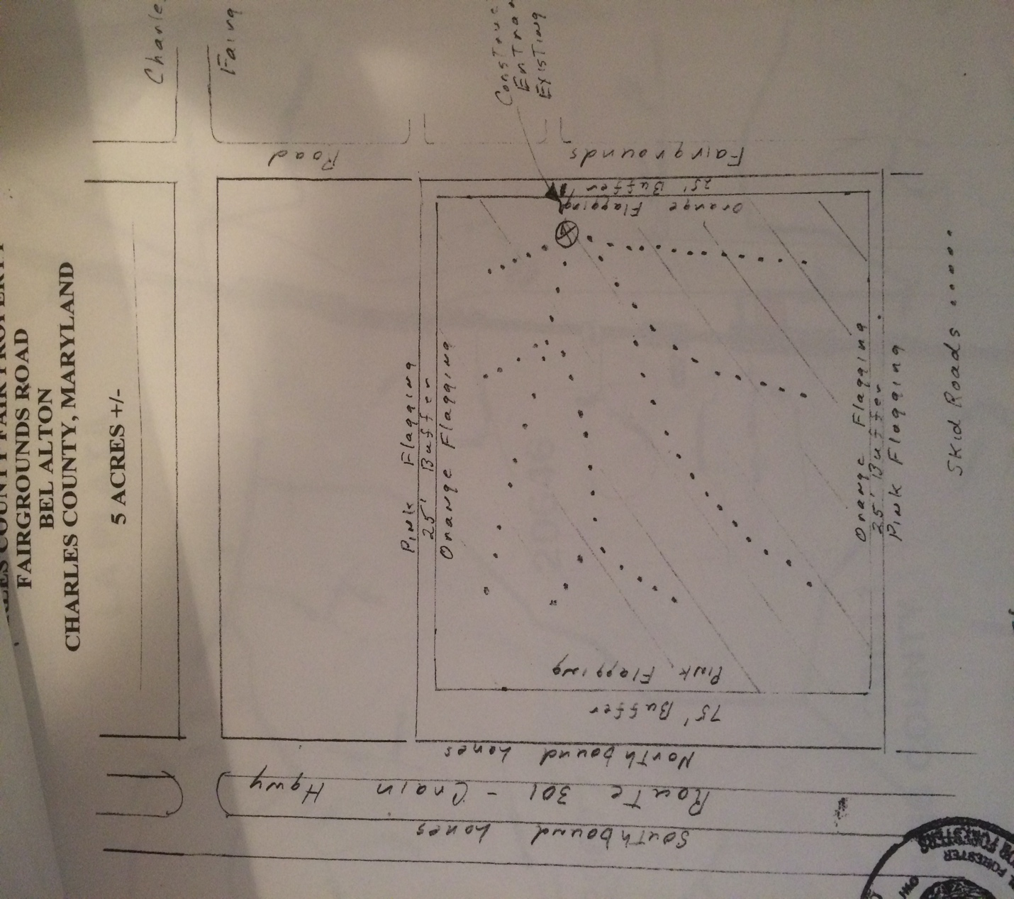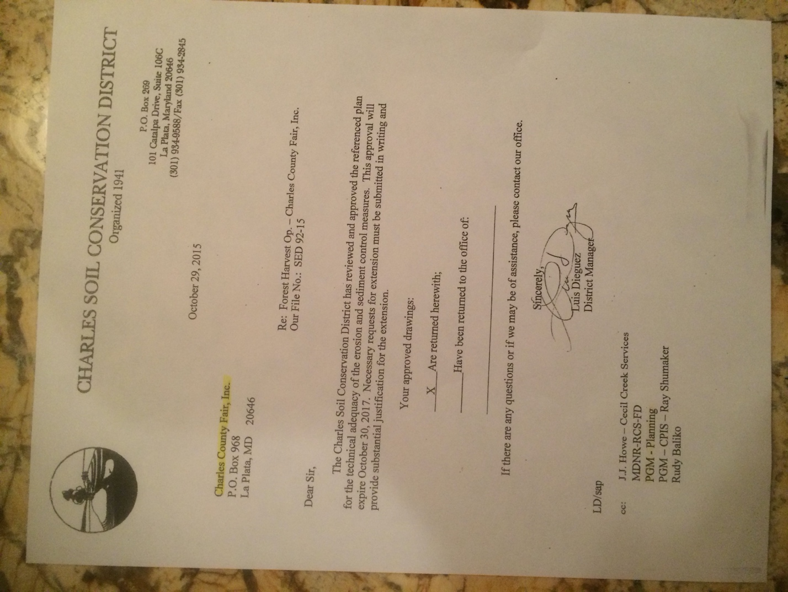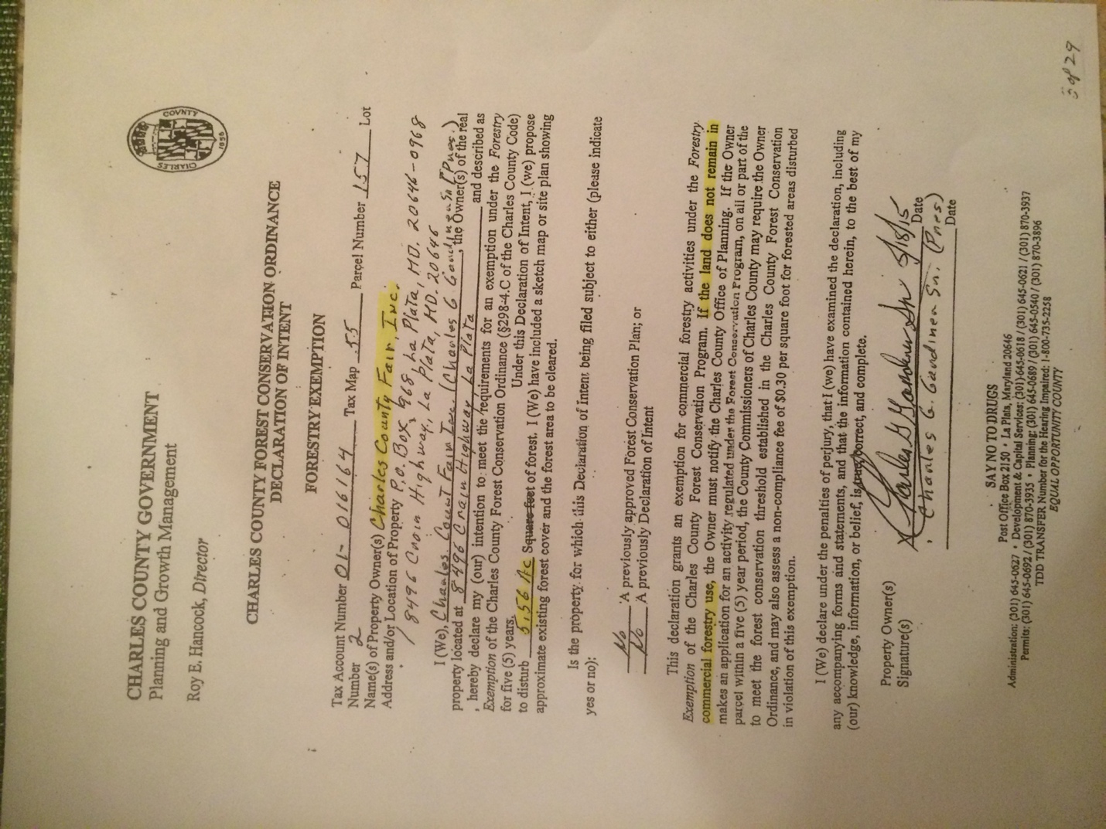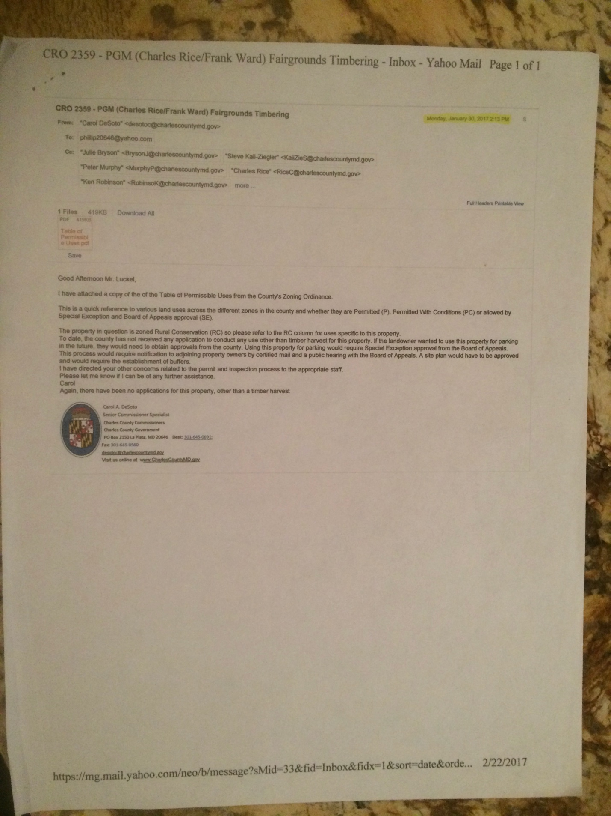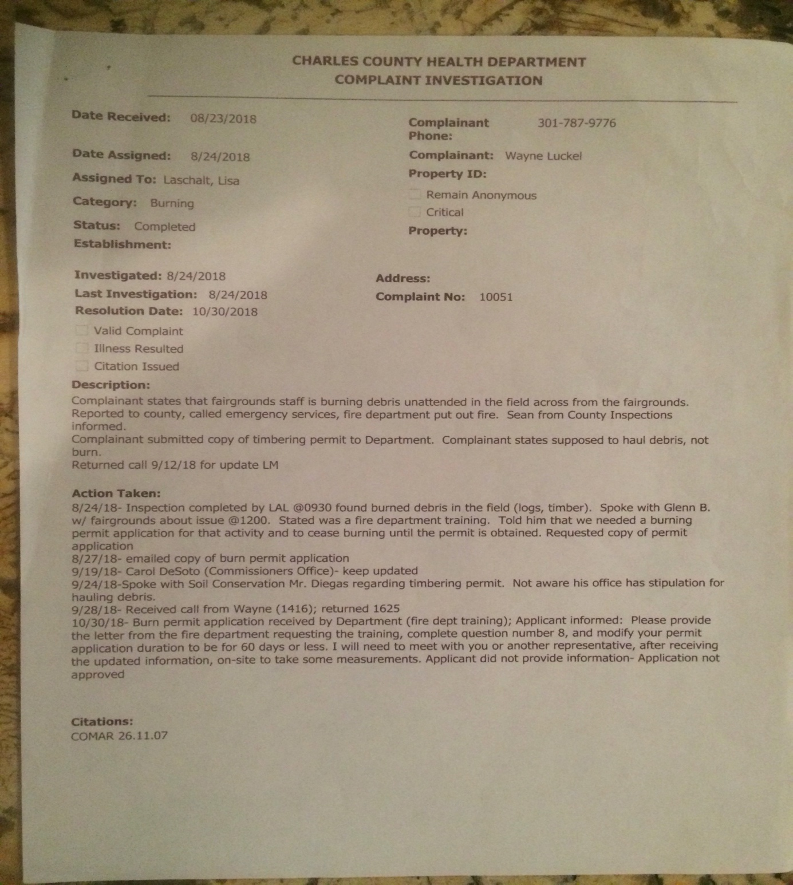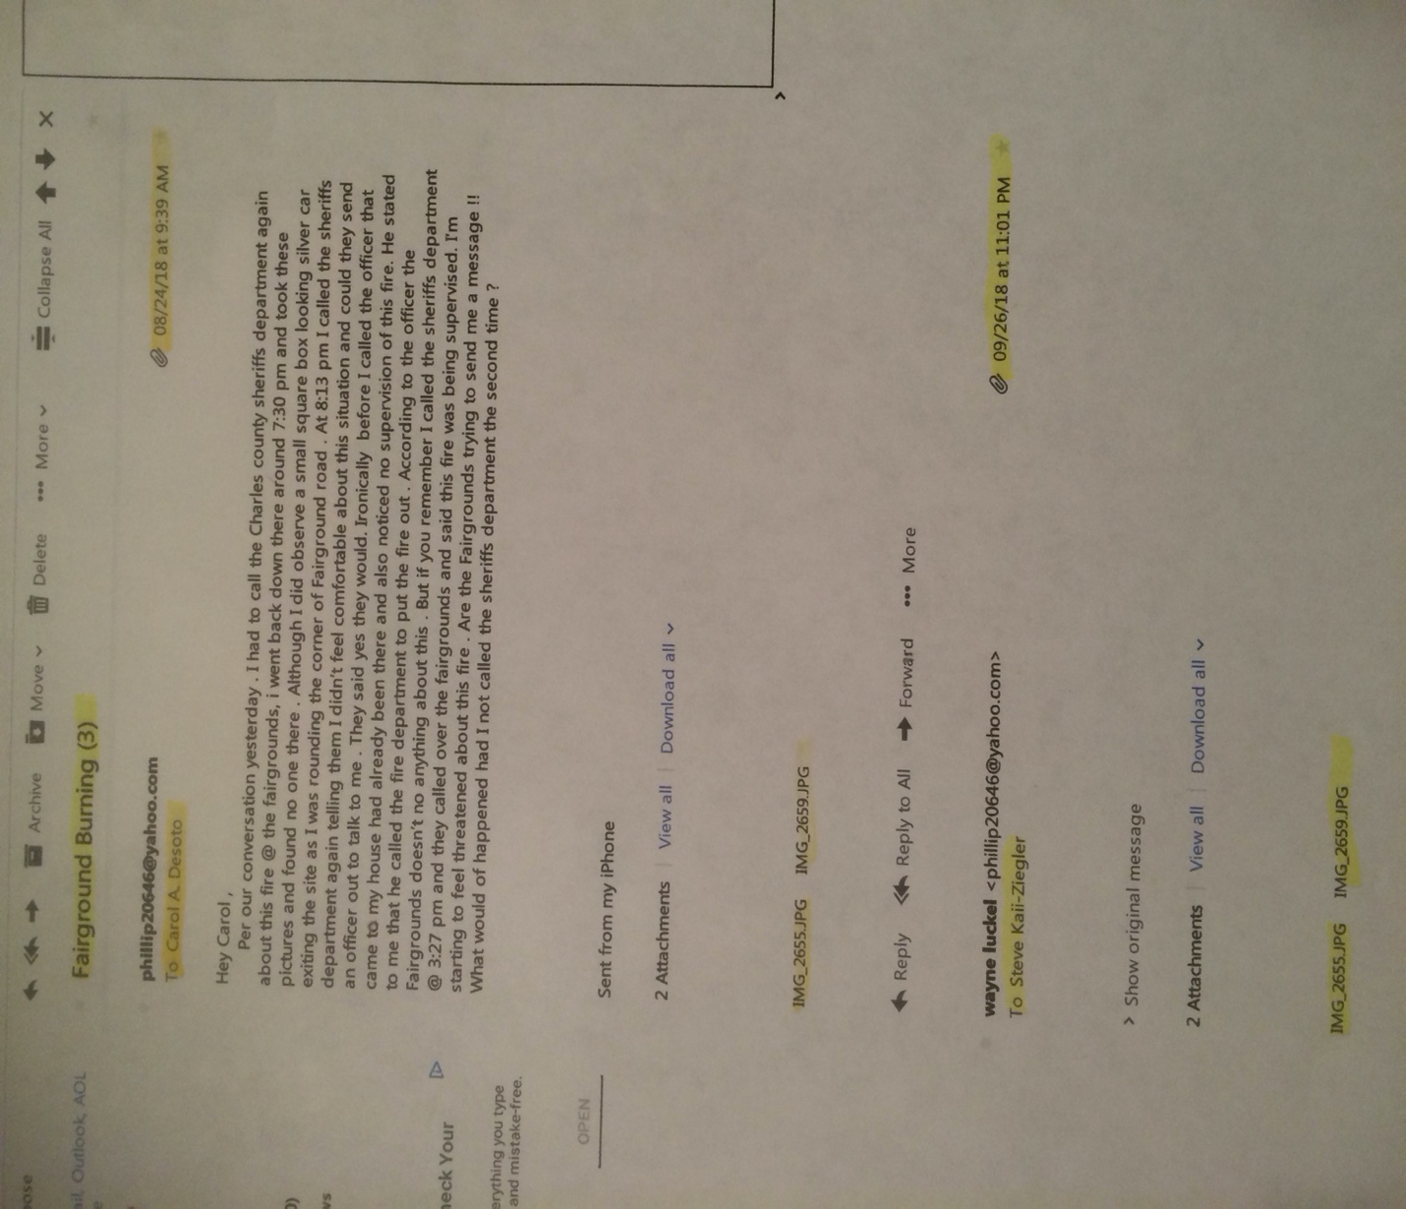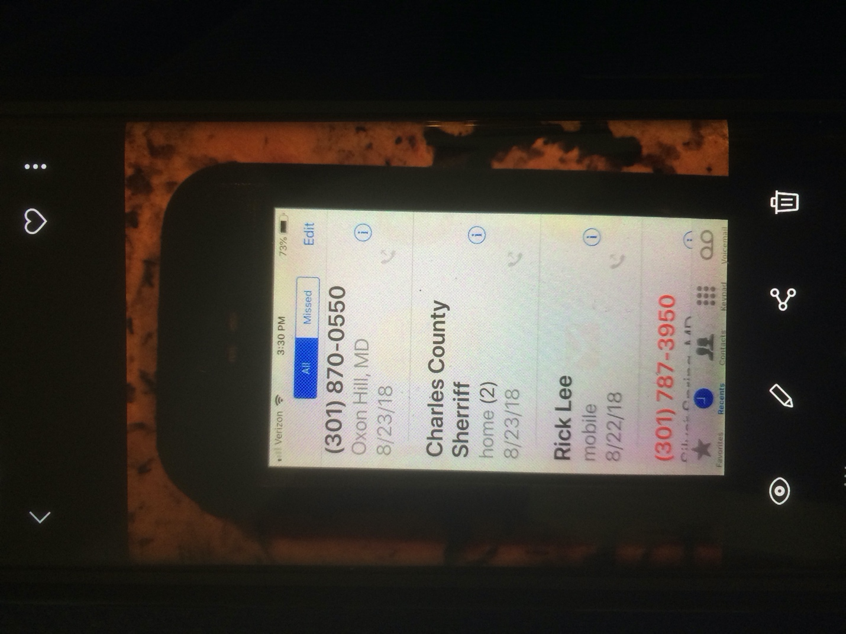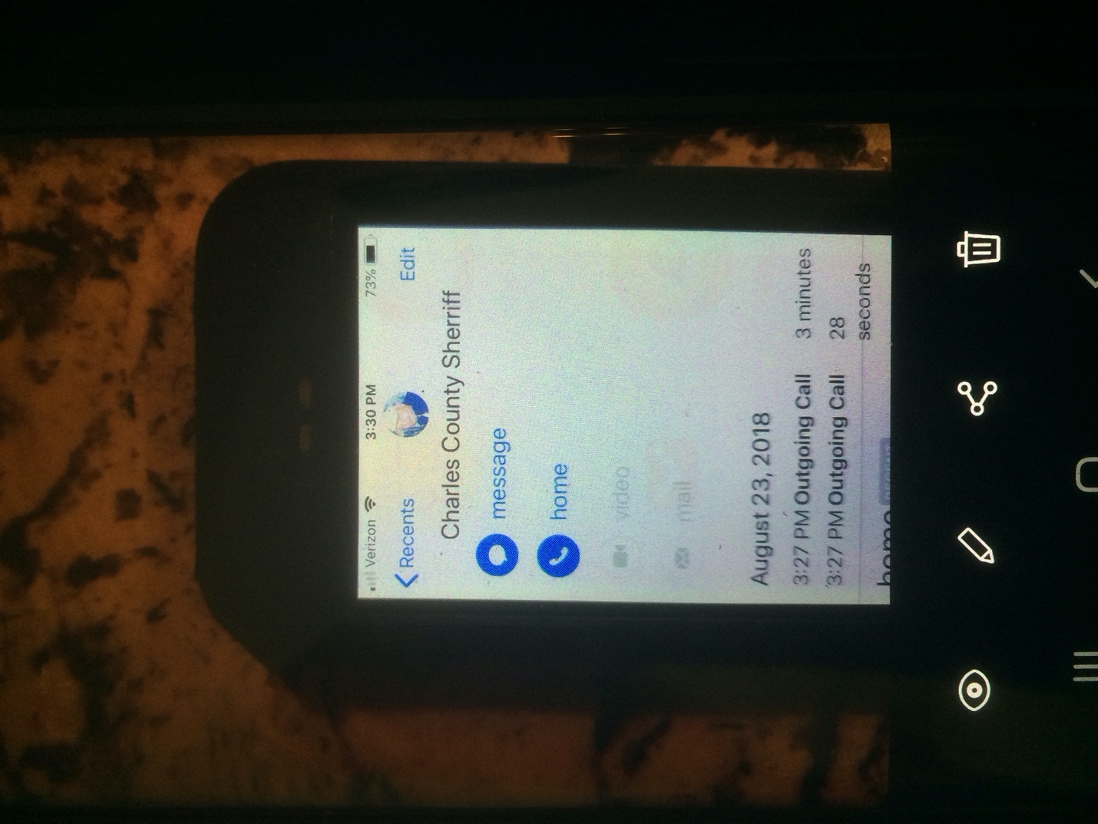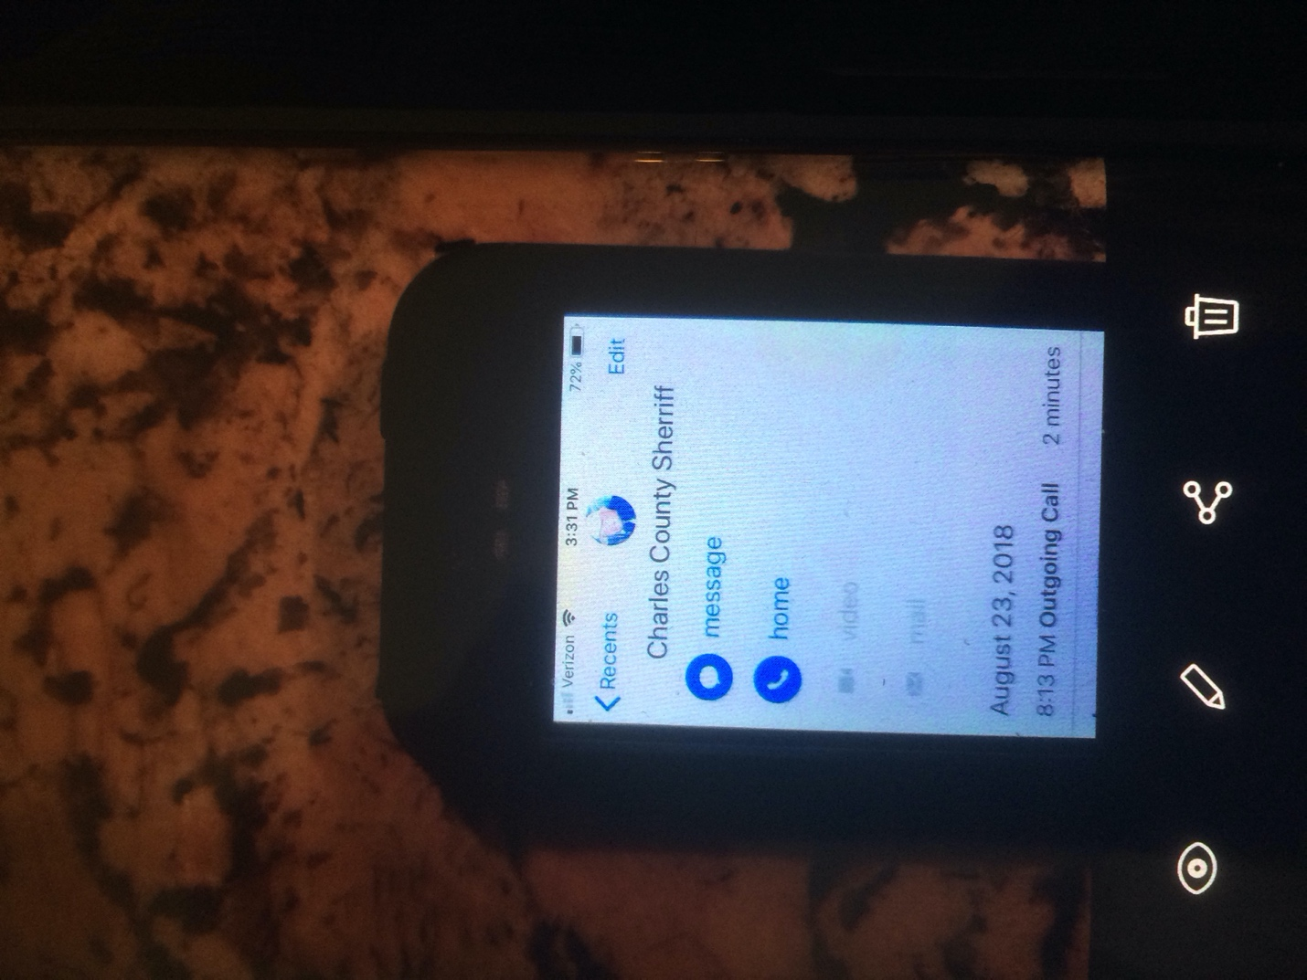
This is Plat 19, Folio 88 of the Charles County, Maryland land Records. The Charles county Fairgrounds bought Lot 2 I am lot 3. This is also identified as (Fair Heights Village) a Minor Subdivision. Keep Scrolling Down.
This is Before the (Charles County Fairgrounds) Timbered Lot 2. Keep Scrolling Down.
This is after the Charles County Fairgrounds Timbered (clear cut) Lot 2. Keep Scrolling Down.
As you can see from the picture above, they the Charles county fairgrounds clearly took out the States 75-foot tree buffer that clearly does not belong to them. Also, they came within 5- feet of my property line which is almost an eighth of a mile. Keep Scrolling Down.
This is the illegal Timbering permit cover page. Keep Scrolling Down.
This folks is why this is an (illegal Timbering Permit). How can this remain in commercial forestry use if the fairgrounds never went through (The Permissible Use Table)? I am in the (Rural Conservation Zone), in which they would have had to file for a (Special Exception) for a (Grass Parking Lot) which in turn would have to go through the (Board of Appeals) which is a Zoning and Land use hearing!! We are Running A Home Rule Local Government Here!! Keep Scrolling Down.

This File (CR02359) created for me on January 30,2017 says exactly what I said about the previous picture above of the (illegal timbering permit)!! Keep Scrolling Down.
This is the Deed for Lot 2 of plat 19, folio 88 of the Charles County, Maryland Land Records. (also known as 8495 Crain highway Laplata, Maryland) A Residential Lot That is part of a minor subdivision called (Fair Heights Village) that the Charles county fairgrounds bought which is map 0055 grid 0007 parcel 0157 of Maryland taxation & assessment (Real Property Search) Keep Scrolling down.

This is the Deed for Lot 2 of plat 19, folio 88 of the Charles County, Maryland Land Records. (also known as 8495 Crain highway Laplata, Maryland) A Residential Lot That is part of a minor subdivision called (Fair Heights Village) that the Charles county fairgrounds bought which is map 0055 grid 0007 parcel 0157 of Maryland taxation & assessment (Real Property Search) Keep Scrolling down.

Destruction on my property from the Fairgrounds Timbering Permit from the storm water runoff and these are older pictures!! Keep Scrolling Down
Destruction on my property from the Fairgrounds Timbering Permit from the storm water runoff and these are older pictures!! Keep Scrolling Down.

Destruction on my property from the Fairgrounds Timbering Permit from the storm water runoff and these are older pictures!! Keep Scrolling Down.

Destruction on my property from the Fairgrounds Timbering Permit from the storm water runoff and these are older pictures!! Keep Scrolling Down.

Charles County health Department (Complaint Investigation) for Fire On 8/23/2018. Keep Scrolling Down.
My Recall of what Happened with the Fire on 8/23/2018.I’ve also provided my call log and pictures of the fire with dates and times to Corroborate my Story. There is also an insert in the Timbering permit (from the Commissioner’s office) that states that the Fairgrounds is not to burn debris, but to haul them away. Keep Scrolling Down.
My Call Log (Charles County Sherriff) 8/23/2018.Keep Scrolling Down
My Call Log (Charles County Sherriff )8/23/2018, with outgoing time 3:27 pm for 3 minutes and 28 seconds. Keep Scrolling Down.
My Call Log (Charles County Sherriff )8/23/2018, with outgoing time 8:13 pm for 2 minutes. Keep Scrolling Down.

Image 2655 Taken 8/23/2018 @ 7:33 pm. Keep Scrolling Down.

Image 2659Taken 8/23/2018 @ 8:34pm. Keep Scrolling Down.
This is the work Retreat Session of February 26, 2019 in which My commissioner of District 1 Gilbert “BJ “ Bowling, III Introduces his Objectives and Goals for 2019. Keep Scrolling Down.
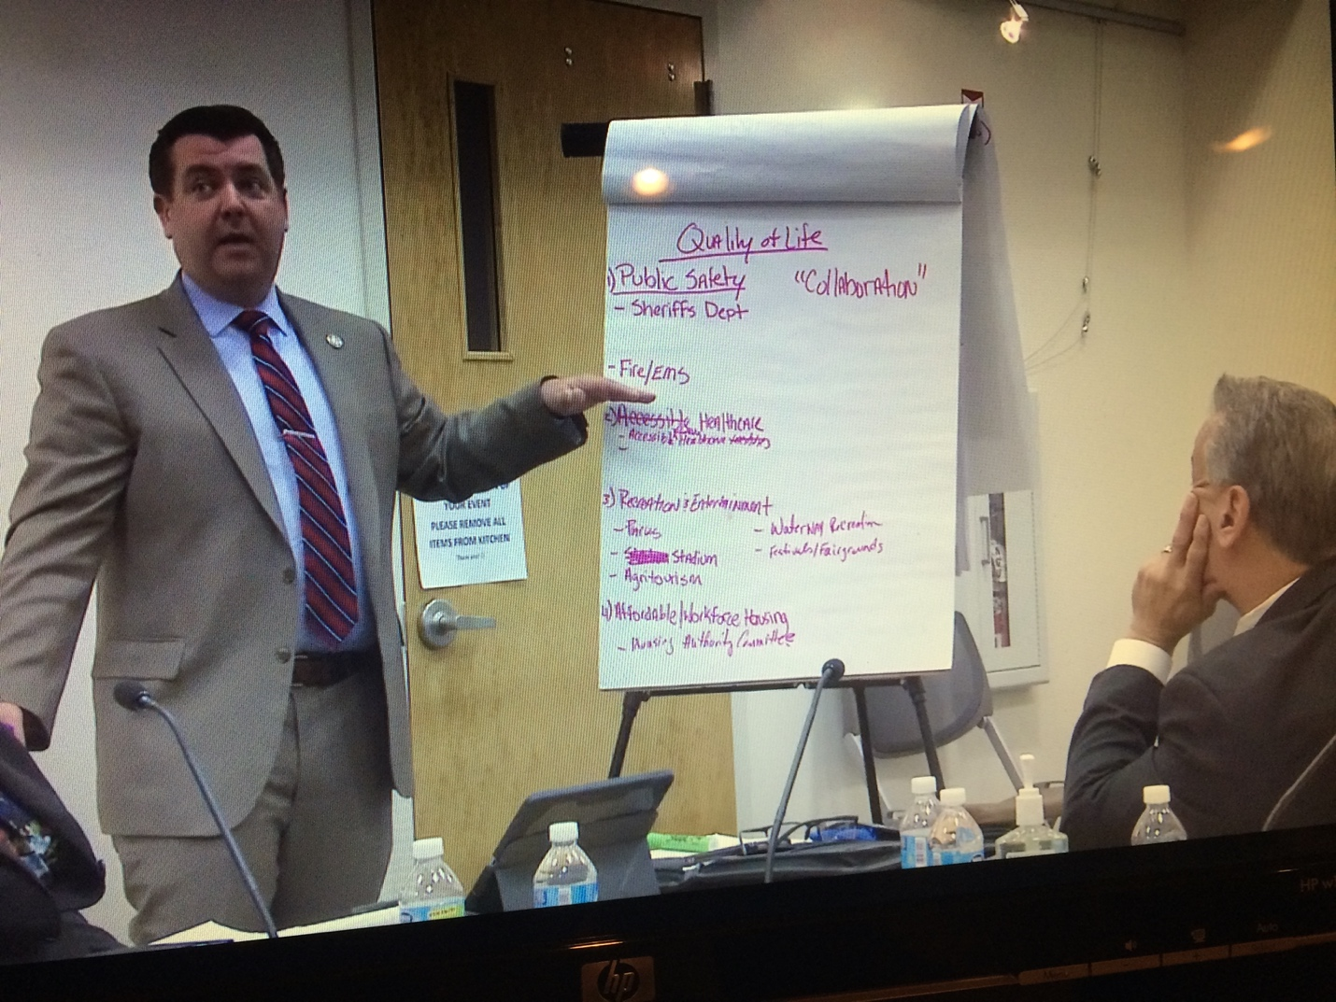

What bothers me most about this is that I met with My District 1 Commissioner Mr. Bowling and top Brass of the Charles County Government about the Fairgrounds Illegal timbering permit, fire and that they bought a residential lot directly behind me that’s part of a Minor Subdivision and yet he still tries to help the Fairgrounds. Look @ number 3 Recreation & entertainment, then look @ the bullet points that say Festivals/ Fairgrounds. Mr. Bowling immediately was told by a fellow commissioner that festivals / fairgrounds should be erased …. Yet he says he and commissioner rucci were talking on how they could help them. This is very Disturbing to me!! This is a man that has worked in Public Safety the majority of his life and should know better!! I have lost all respect for Mr. Bowling!! Keep Scrolling Down.

A Task Force was Created by Commissioner Bowling. This is (The Rural Planning and Zoning Task Force) Mission Statement. Don’t you think there is a reason why we have Maryland public safety 12-508!! But yet here we are…... Keep Scrolling Down.

This is (proposed revisions) from the task force recommended by questionable PGM staff that did participate. They may say they didn’t, but there is Recordings to back up what I am saying!! Keep Scrolling Down.

Conditions for Agritourism …...This is what I’m talking about!! The Charles County Fairgrounds is Agritourism!! Also, I am in the (Rural Conservation Zone). Notice they want this allowed without any conditions? How about a (5-acre Grass Parking Lot). You see folks this is how you get around the permissible use table, filing a special exception and going to a board of appeals hearing. Especially when you have done something illegal!!

