Sending a NON-EMERGENCY TEXT & EMAIL NOTIFICATION using Everbridge
Upon logging in to the CNS System at https://manager.everbridge.net/login
Your default role will be “ES_Dispatcher”

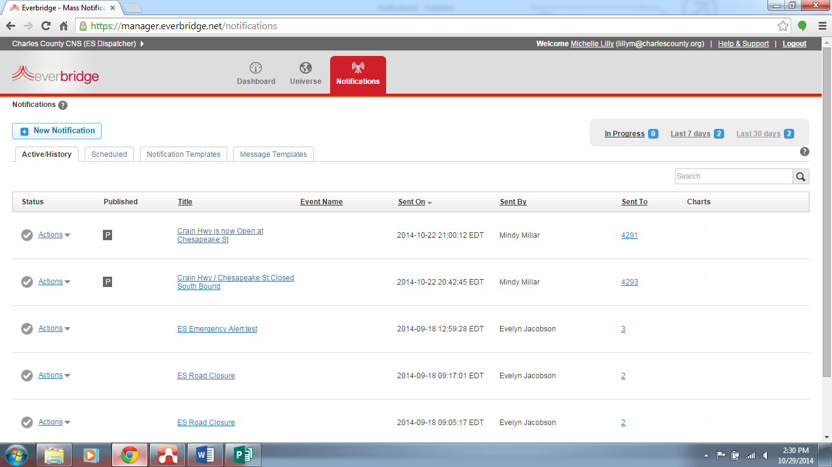
Default login screen is ES_Dispatcher
Notification Templates Tab

Go to the Notification Templates tab and click the pencil icon for the non-emergency notification type you wish to edit & send.

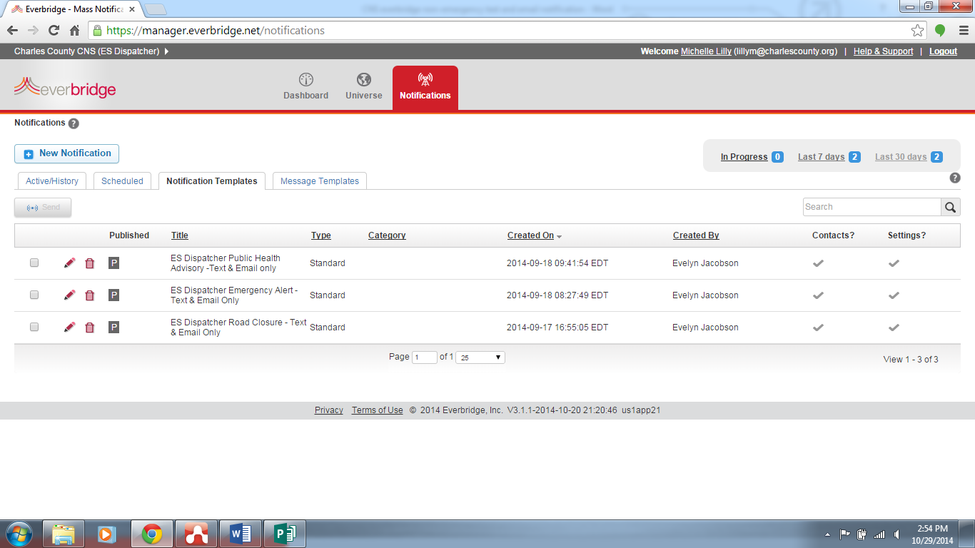
Select the pencil to edit the template
All ES_Dispatcher templates are text & email ONLY

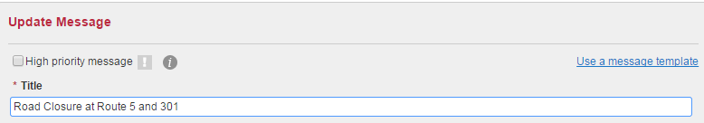

Type a title for this notification. e.g., Road Closed at Route 5 and 301

Body (checked)
Allows creation of a separate message for email. If unchecked, the text entered below will be sent in the body of the email.
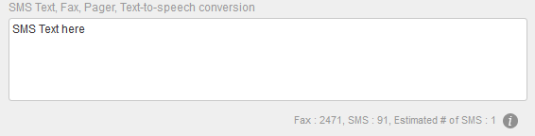
Watch your character count & # of SMS texts. You have 120 characters to use between the title and SMS box. DO NOT SEND more than one SMS.
Do not repeat the title in the SMS box. The title becomes the first line of the text when you send.

Type the message for text devices
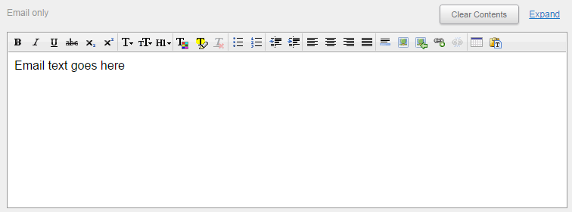

Type the body of the email.
For the Road Closure Template there is a map reference link to the County’s Road Closure map. DO NOT delete the map reference when sending Road Closures. Be sure you have added the road closure to the CAD before sending the CNS.

Scroll to the bottom of the page.
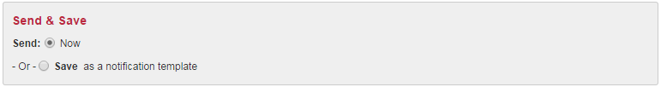
Send & Save options
- Now (checked) –check Now to send the notification immediately
- Save as a notification template (unchecked) – do not check this option to save as a notification template as it will overwrite the current template
VERY IMPORTANT… click the Send button to send the notification; make sure the button says Send.

