Sending an EMERGENCY MAPPED PHONE CALL, TEXT & EMAIL NOTIFICATION using Everbridge
Upon logging in to the CNS System at https://manager.everbridge.net/login
Your default role will be “ES Dispatcher”
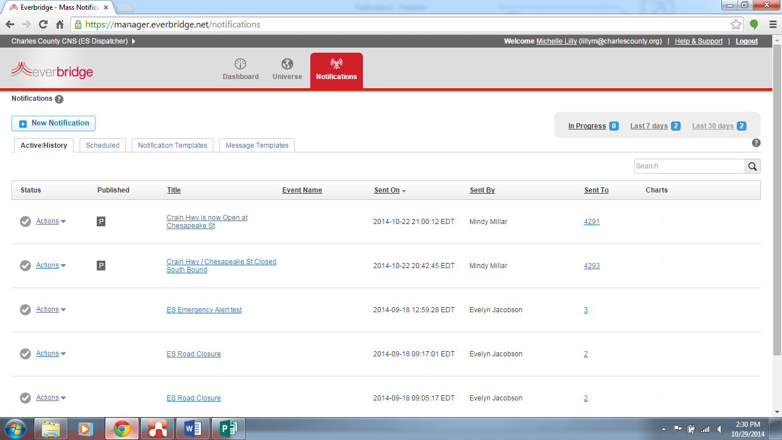
Default login screen is ES Dispatcher

In order to send out a phone call to the 9-1-1 database (all Verizon & Comcast landline phones) and CNS subscribers, you must change your role to “ES Dispatcher with 911”
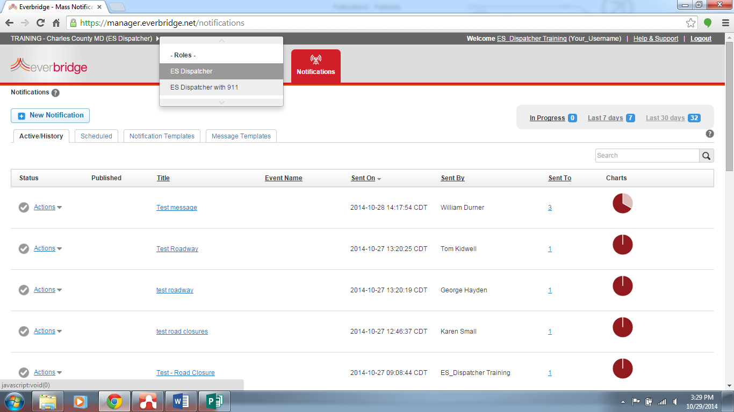
Click on ES Dispatcher to get the Roles menu.
Click on ES Dispatcher with 911

After changing your role, go to the Notification Templates tab and click the pencil icon for the emergency notification type you wish to edit & send.
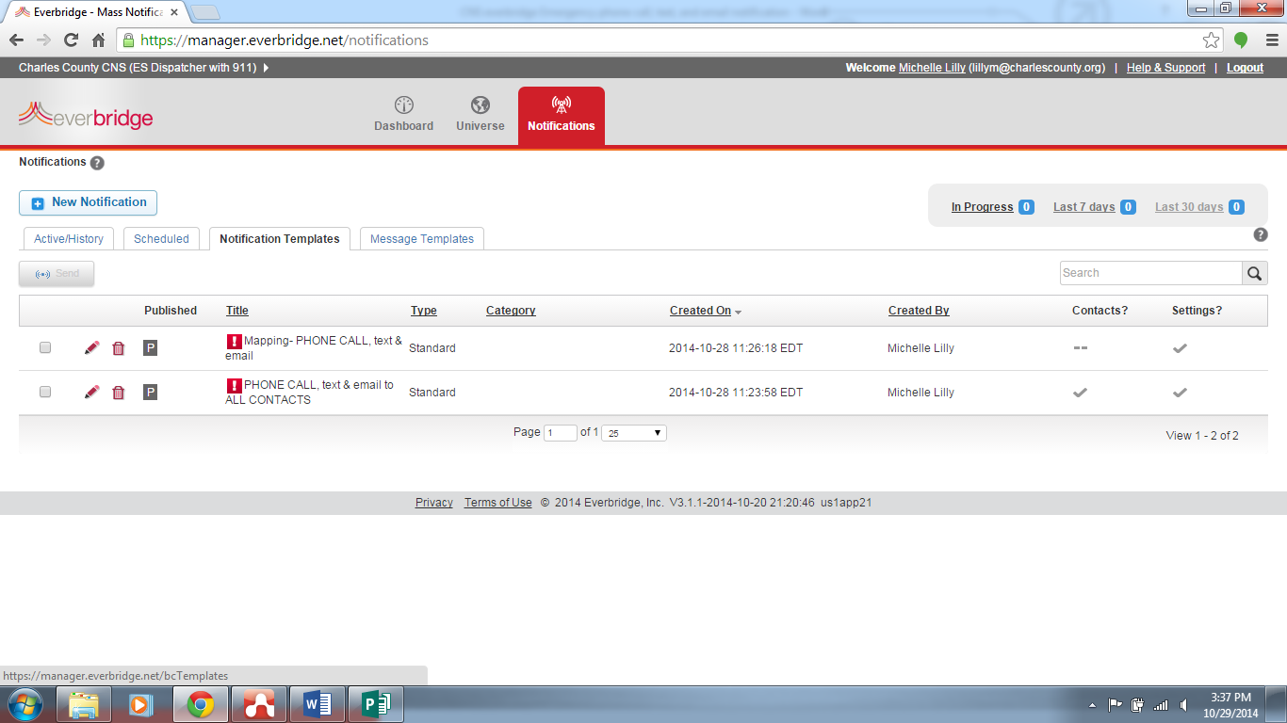
Select the pencil to edit the template.

There are only two templates in “ES Dispatcher with 911” role for Emergency Phone Calls, text & email:
- Mapping PHONE CALL, text & email – you must select the contacts on a map to complete the notification.
- PHONE CALL text & email to ALL CONTACTS – this template will call EVERYONE in our system, which is approximately 78,000 phone calls. Please use caution!

-Select the Mapping-PHONE CALL, text &email template.
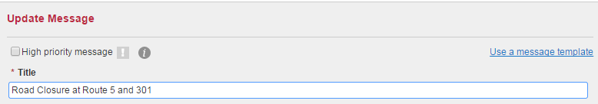

Type a title for this notification. e.g., Road Closed at Route 5 and 301

Body (checked)
Allows creation of a separate message for email. If unchecked, the text entered below will be sent in the body of the email.
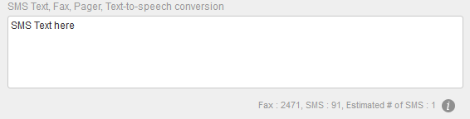
Watch your character count & # of SMS texts. You have 120 characters to use between the title and SMS box. DO NOT SEND more than one SMS.
Do not repeat the title in the SMS box. The title becomes the first line of the text when you send.

Type the message for text devices
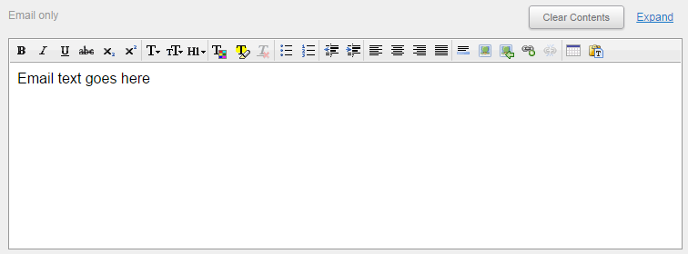

Type the body of the email.

Check the “Include a Voice Recording” box and then select the “Use a telephone” button.
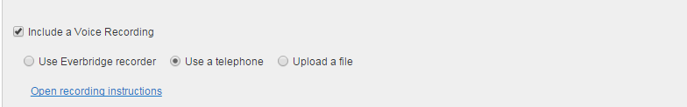

Click the blue writing to open recording instructions.
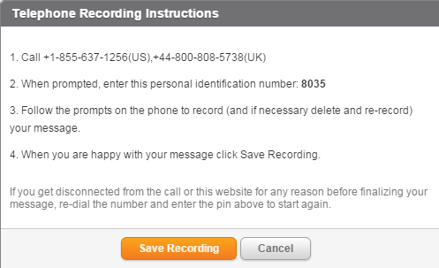
The PIN will change each time the recording instructions are opened.

Call the phone number and follow the voice prompts.
When you are done, click the orange “Save Recording”
button.

After you have completed typing out the text/email and have recorded your phone message, scroll down the page to the “Select Contacts” box.

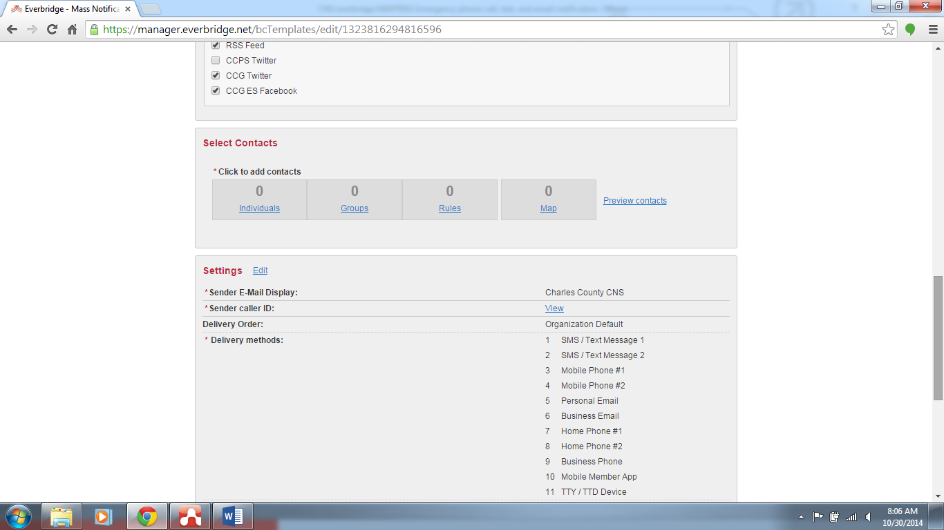
Click on “Map” to select contracts from the map.

How to select mapped contacts by address search or name.
When you click the “Map” button, the mapping interface pops up. There are several ways to select contacts from the map. The first option is to search the map by location or by contacts. Contacts can include the 9-1-1 database or CNS subscribers.
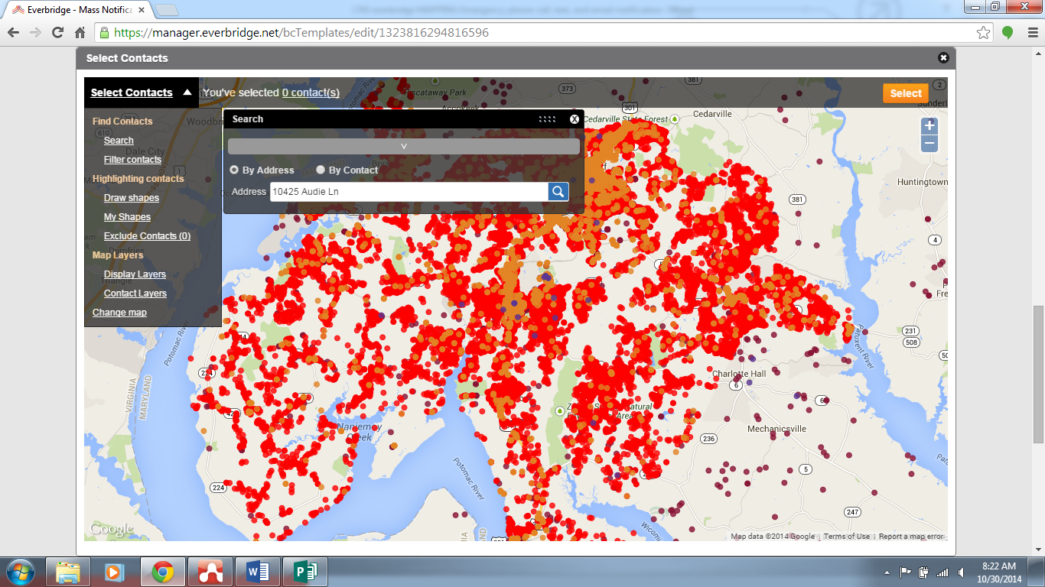
Click “Select Contacts “ to get the map menu.
Click “search” to find an address or contact in the 9-1-1 database.
Enter the address in the box and press enter.

After you search the address you can set a marker or you can draw a circle around the address or contact’s location.
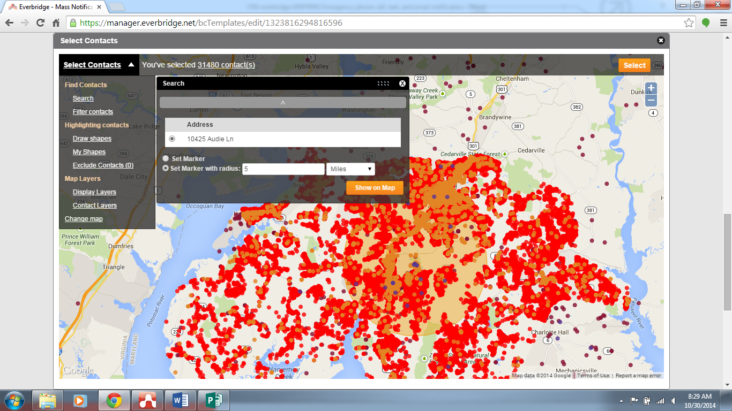
Set a Marker with a radius from the location. Click “Show on Map”.
The shape has selected 31,480 contacts to be called.
Click “Select” to send to the selected contacts.

How to exclude contacts from the notification

After selecting contacts, you may exclude one or more contacts that you do not wish to notify. This may be useful for barricade situations or similar.

You can search by name or address.
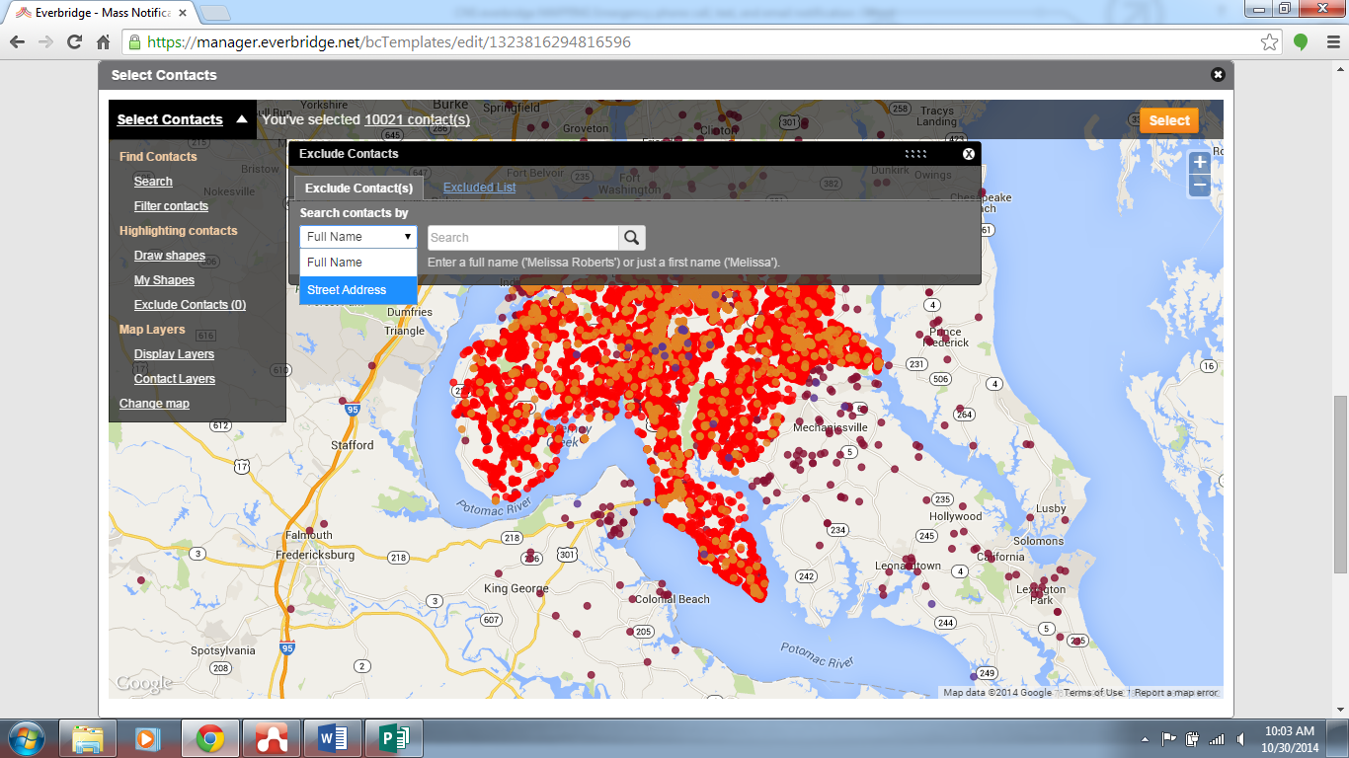
Select the “Exclude Contacts” menu
Search by Full Name or by Street Address

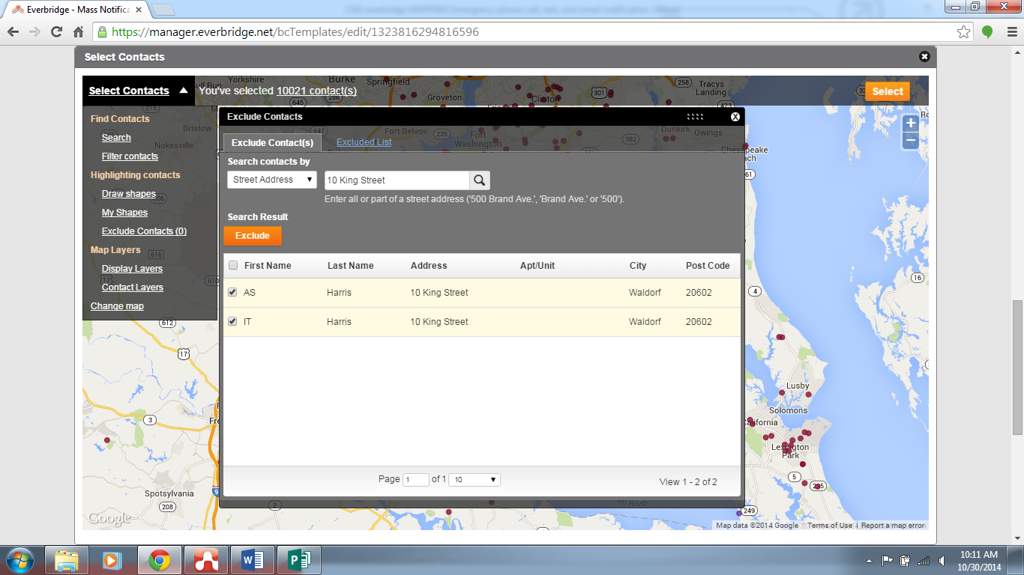
Check the box beside the name of whom you wish to exclude.
After selecting the names, click “Exclude”

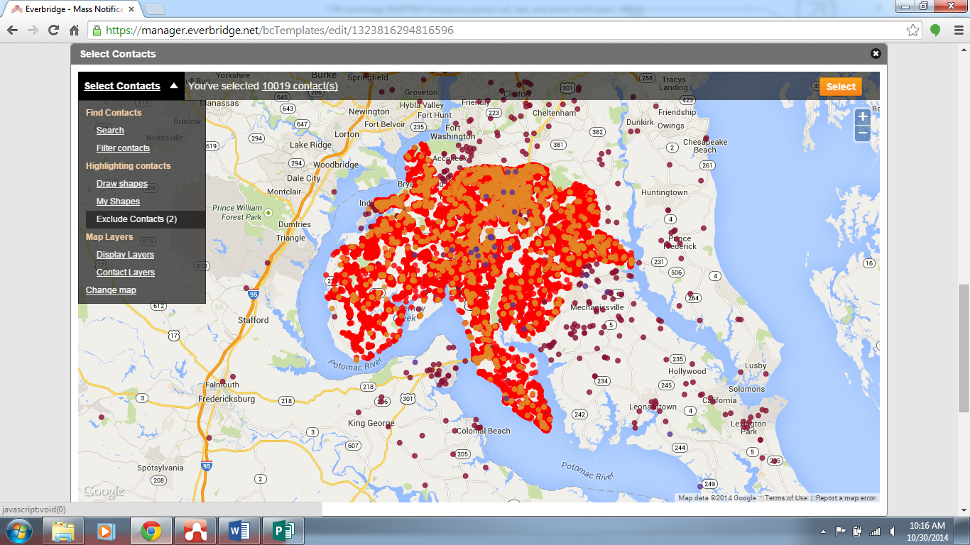
The menu will now show that you have excluded contacts and the number of contacts excluded.

How to select mapped contacts by shape
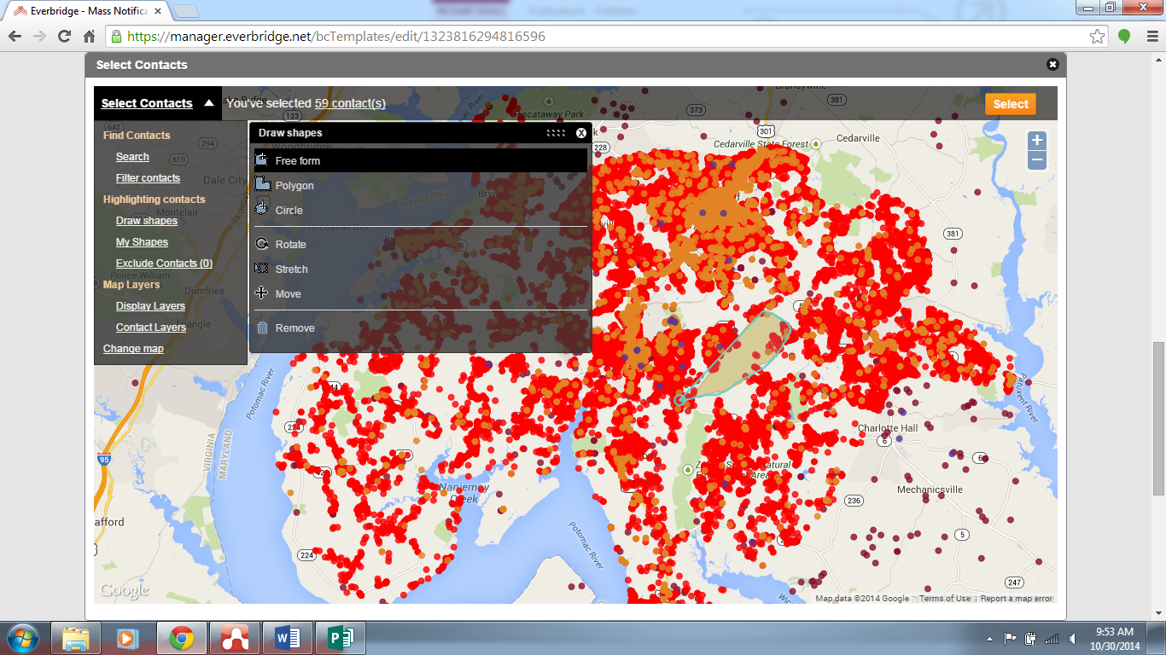
Free Form– click & hold the mouse button while you draw your shape to select contacts.
Click “Draw Shapes” to get the menu to popup.
Polygon– click multiple times to create points . When done double click to end the drawing and select contacts.
Circle—click, hold & drag the circle to it’s desired size.

Click “Select” to send to the selected contacts.

Descriptions & Definitions of each mapping feature:
- Free Form – Drawing tool to draw a free form shape. To draw, click on the “Free form” menu item. Click the left mouse button & hold while you draw. When the left mouse button is released the contacts inside the shape will be selected.
- Polygon – Drawing tool to draw a polygon shape. To draw, click on the “Polygon” menu item. Left click the mouse for each point of the polygon you wish to draw. Double click the final point to end the drawing and select contacts within the shape.
- Circle – Drawing tool to draw a circle shape. To draw, click on the “Circle” menu item. Left click & hold while you drag the circle to the desired size.
- Rotate – Tool to modify/rotate the shape that you have drawn on the map. To modify a shape, click on the “Rotate” menu item. Left click the mouse on the shape you wish to modify, the shape will turn orange and a dark orange dot will appear. Left click on the dot to rotate the shape. Click anywhere on the map to accept the modified shape.
- Stretch – Tool to modify/stretch the shape that you have drawn on the map. To modify a shape, click on the “Stretch” menu item. Left click the mouse on the shape you wish to modify, the shape will turn orange and multiple dark orange dots will appear. Left click on the dots to increase/decrease the size of the shape. Click anywhere on the map to accept the modified shape.
- Move – Tool to move the shape that you have drawn on the map. To move a shape, click on the “Move” menu item. Left click the mouse on the shape you wish to move, the shape will turn blue and a white plus sign will appear. Left click & hold to drag the shape where desired.
- Remove – Tool to remove shapes on the map. Left click the shape you wish to remove. A black circle with an X inside will appear. Click the X to remove the shape and unselect contacts within the shape.

After mapped contacts have been selected

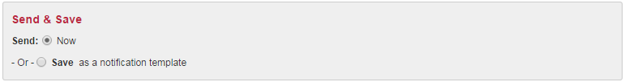
Scroll to the bottom of the page.
Send & Save options
- Now (checked) –check Now to send the notification immediately
- Save as a notification template (unchecked) – do not check this option to save as a notification template as it will overwrite the current template
VERY IMPORTANT… click the Send button to send the notification; make sure the button says Send.

