Sending an EMERGENCY PHONE CALL, TEXT & EMAIL NOTIFICATION using Everbridge
Upon logging in to the CNS System at https://manager.everbridge.net/login
Your default role will be “ES_Dispatcher”
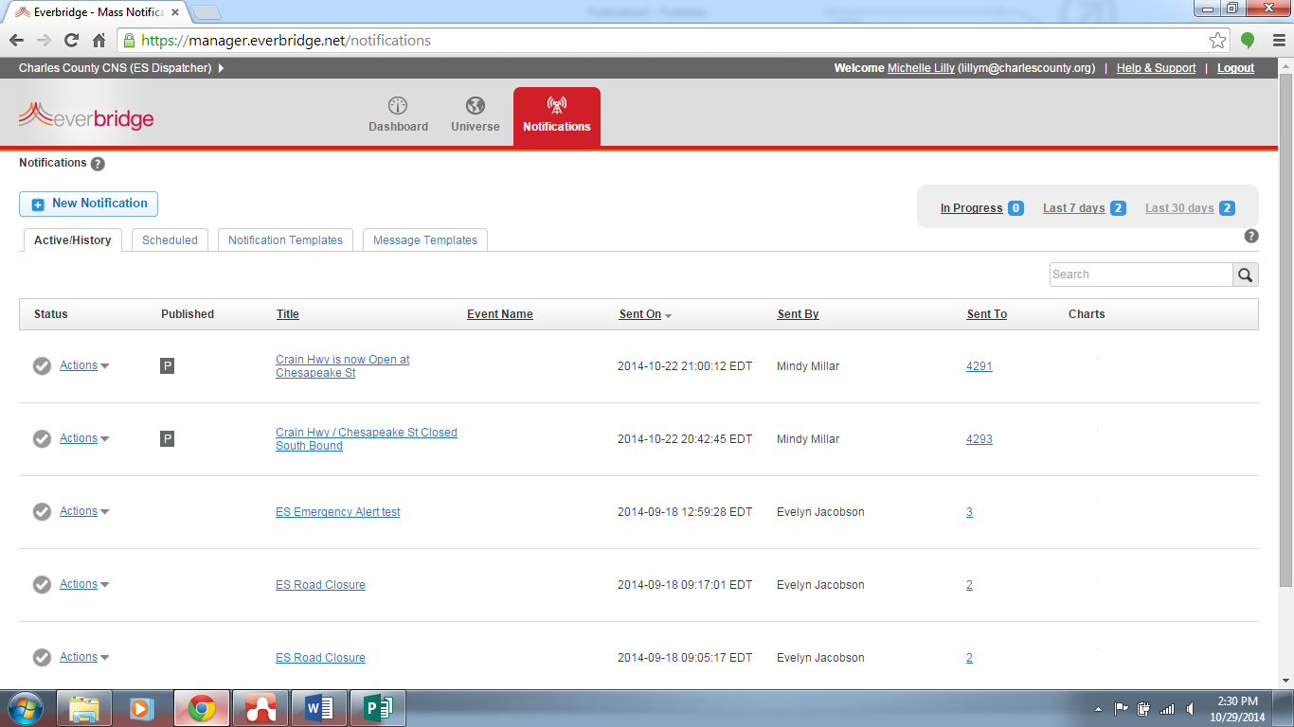
Default login screen is ES Dispatcher

In order to send out a phone call to the 9-1-1 database (all Verizon & Comcast landline phones) and CNS subscribers, you must change your role to “ES Dispatcher with 911”
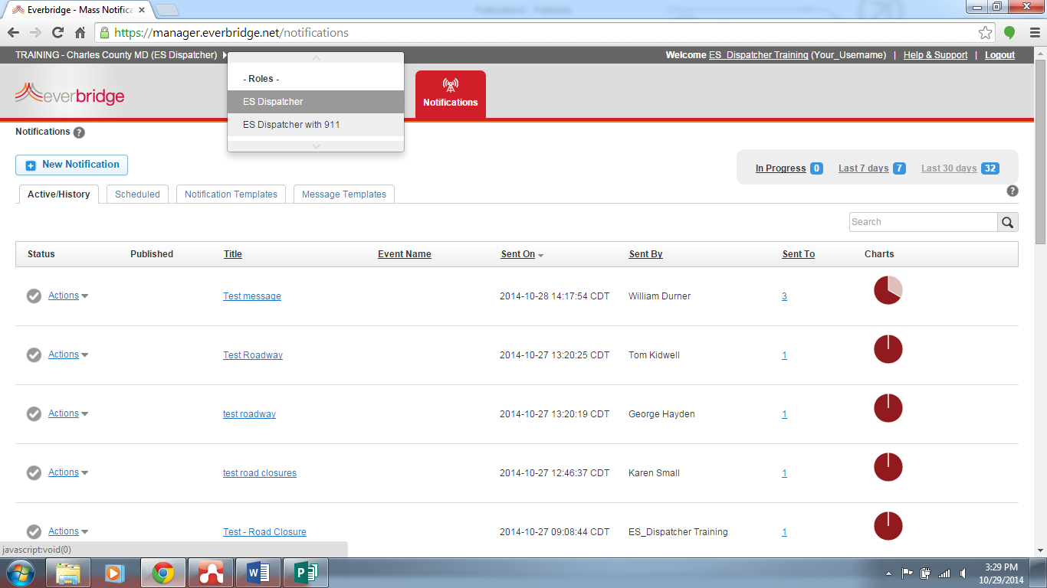
Go to the Notification Templates tab and click the pencil icon for the emergency notification type you wish to edit & send.
Click on ES Dispatcher to get the Roles menu.
Click on ES Dispatcher with 911
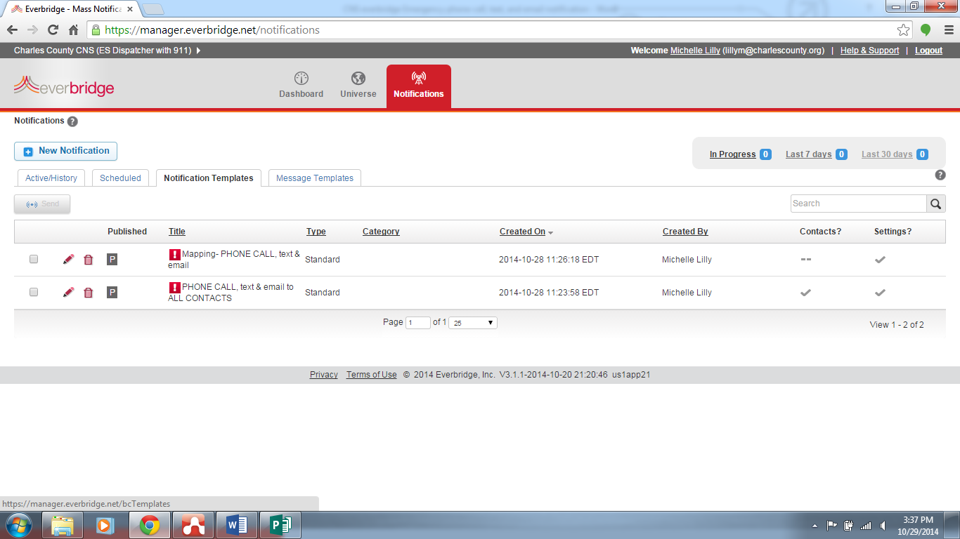
Select the pencil to edit the template.

There are only two templates in ES Dispatcher with 911 for Emergency Phone Calls, text & email:
- Mapping PHONE CALL, text & email – you must select the contacts on a map to complete the notification.
- PHONE CALL text & email to ALL CONTACTS – this template will call EVERYONE in our system, which is approximately 78,000 phone calls. Please use caution!
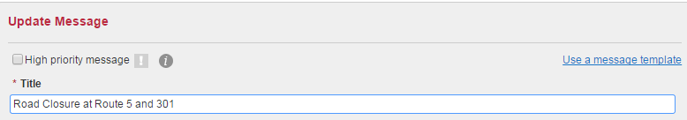

Type a title for this notification. e.g., Road Closed at Route 5 and 301

Body (checked)
Allows creation of a separate message for email. If unchecked, the text entered below will be sent in the body of the email.

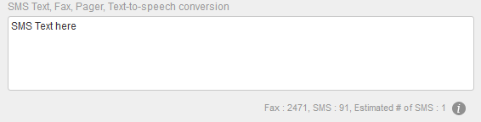
Watch your character count & # of SMS texts. You have 120 characters to use between the title and SMS box. DO NOT SEND more than one SMS.
Do not repeat the title in the SMS box. The title becomes the first line of the text when you send.

Type the message for text devices
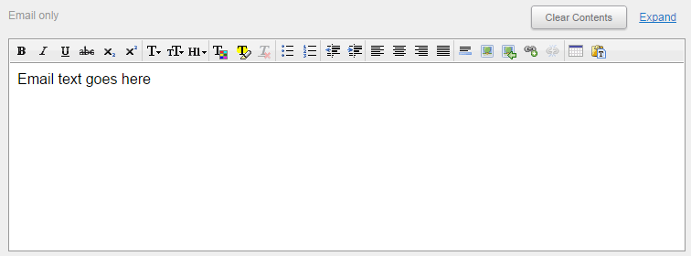

Type the body of the email.

Check the “Include a Voice Recording” box and then select the “Use a telephone” button.
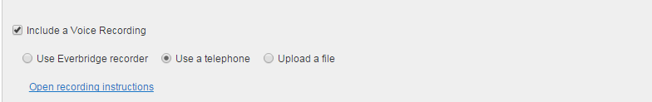

Click the blue writing to open recording instructions.
The PIN will change each time to open the recording instructions are opened.
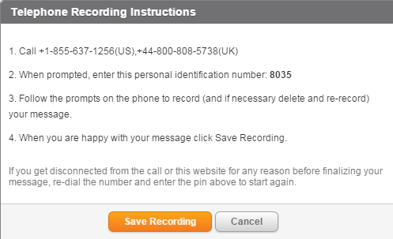

Call the phone number and follow the voice prompts. When you are done, click the orange “Save Recording” button.

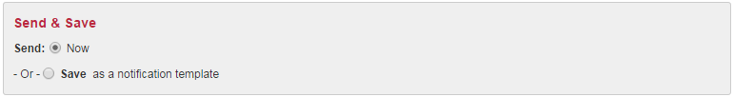
Scroll to the bottom of the page.
Send & Save options
- Now (checked) –check Now to send the notification immediately
- Save as a notification template (unchecked) – do not check this option to save as a notification template as it will overwrite the current template
VERY IMPORTANT… click the Send button to send the notification; make sure the button says Send.

