Operational Changes Due to the Coronavirus
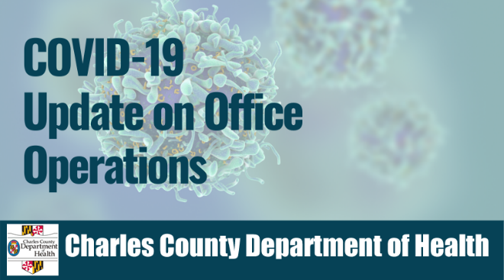
Due to the current State of Emergency, effective March 17, 2020 at 3:00 p.m. the Charles County
Department of Health’s offices will be closed. Limited services may be provided remotely to
reduce the risk of customer exposure to COVID-19.
Vital Records Office
- To place an order for a birth certificate or death certificate:
- Application forms and detailed information for ordering vital records or requesting
amendments may be found at www.health.maryland.gov/vsa
- By Mail – Mail forms to Division of Vital Records P.O. Box 68760 Baltimore, MD 21215
- By Internet – www.VitalChek.com
- By Phone – (410) 764-3038 option 1
- General Inquiries may be made by phone at (410) 764-3038 option 2

Clinical Services
The following services will be closed:
- Dental
- Reproductive Health
- Sexually transmitted infections (STI) testing
- Maryland Children’s Health Program
- Adult Evaluation and Review (AERS)
General inquiries may be made by phone at (301) 609-6900.

Women, Infants and Children (WIC)
The Southern MD WIC Program will continue to issue food benefits electronically for all
eligible program clients. Onsite WIC clinic services have been temporarily discontinued to
reduce the risk of customer exposure to COVID-19.
For questions about the WIC program benefits or services
email charlecounty.wic@maryland.gov . The WIC program staff will respond to emails as soon
as possible.
Infants and toddlers and disability services will be available remotely. Contact 301-609-6831 or
301-609-6808 for further information.

Environmental Health Services
In person services will be discontinued in the environmental health office. Limited field services
may be provided. Contact 301-609-6751 for environmental health questions or service
availability.

Local Behavioral Health Authority (LBHA)
In person services from the LBHA will be discontinued. For assistance contact
mdh.charlescoutyCSA@maryland.gov or 301-609-5757 fax 301-609-5749.

