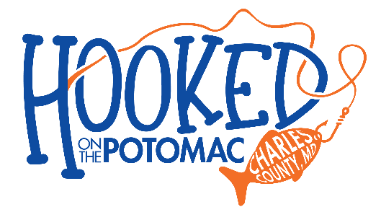
Charles County Department of Recreation, Parks and Tourism is hosting a brand-new festival, Hooked! on the Potomac, taking place in Indian Head, Maryland on June 28-29, 2025. We are looking for organizations like yours to join us!
This multi-faceted fish-themed event will feature programming that highlights recreational fishing, aquatic conservation/invasive species impacts, and delicious local seafood. Our event takes place in conjunction with Major League Fishing’s (MLF) Bass Pro Tour- Stage 6, a top-level competitive bass fishing circuit featuring the world’s best anglers.
We are reaching out to partners, like you, in the hopes that you would like to:

- Host a family-friendly activity
- Provide and staff an information table (information applicable to event theme)
- Sell food or non-food items as a vendor
- Donate branded swag items

Attending our event as a vendor is not only a great way to create brand recognition in the local area, but also an opportunity to connect with both the Charles County and Major League Fishing communities. Click the included link below and follow the steps to submit a vendor application. For more information, please reach out to Rachel Williams, at williamRA@charlescountymd.gov.
Event Information
Location: Village Green Park, 100 Walter Thomas Road, Indian Head, MD 20640
Date: June 28-29, 2025 | Time:1:00pm -6:00 pm

The Hooked! application is open until April 28th
- Start your application here: https://charlescountymd.activityreg.com/selectactivity_t2.wcs?leaguesid=115
- Create an account with our website (you can make a personal or organization account)
- Food vendors- head to the Account Information tab upload your Certificate of Insurance and Health Department Permits under the Documents section
- Submit your application
- If approved, payment instructions will be sent

