CC is implementing the 2012 draft BGI Plan-not the citizen-supported
2016 Comp Plan
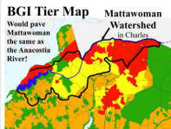 | 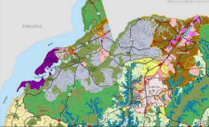
Balanced Growth Initiative Draft 2016 Comprehensive Plan
Airport Aviation Zone (ABP) - the BOCC will soon hold a hearing, on April 9. In 2019 the 215-acre private airport sold for 2 1/2 million dollars, to PSM Holdings, LLC. PSM already owns 183 acres in the Watershed Conservation District, surrounding the airport. The rezoning will create a 400-acre private airport. The zoning change creating a large airport is a point that has never been shared in the rezoning process. The county states the purpose of the rezoning: “The proposal does not include rezoning of the Airport facility properties.” (see legend for airport ownership parcels) - The airport almost doubles in size! More lead exhaust and pollution.
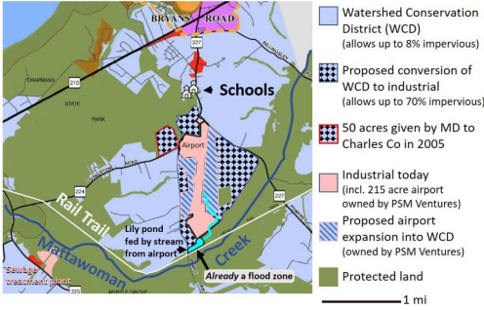

Bryans Road Sub Area Plan - passed by BOC - but completely inconsistent with the 2016 Comprehensive Plan. Is CC must have an amendment to the Comp Plan or new Comp Plan to implement the new Bryans Road Sub Area Plan. Most of the new housing in the Bryans Road Sub Area Plan, is proposed on sensitive land in the WCD. DNR voiced serious concerns, but they were never discussed in the planning process. Serious problems with public outreach in the BR Sub-area Plan process.
CC is working to break West End Senior housing, out of the BR Sub-area Plan with a ZTA which is before the CC Commissioners, with an open record until 4:30 pm March 8, 2024.

Zoning Text Amendment (ZTA) #22-170 on the WCD
The Board of County Commissioners approved ZTA #22-170 WCD on 11/14/2023. There are issues of transparency with this process. The 8/21/2023 Staff Report to the Planning Commission includes a section entitled Background. This Background did not include the following clause found in Bill No 2017-03 Watershed Conservation District (ZTA 16- 142): WHEREAS, the new Comprehensive Plan includes changes in land uses to the Bryans Road area to limit expansion of residential and commercial development to a village size. This clause is important because it confirms that the WCD is consistent with the Comprehensive Plan after the Airport Comp Plan Amendment. separate details-upon request.
ZTA#21-165 Independent Living Senior Housing Complex (located in the WCD) Record before the CC Commissioners, (after hearing) closes on Friday March 8th - at 4:30 pm.
The majority of Commissioners have voted to support ZTA #21-165, but have allowed the comment period to give the staff an opportunity to change the proposal in order to follow the rules. (change proposal after the public hearing? ) Staff does no/did not support this ZTA because it is inconsistent with the goals and intent of the WCD. The PC was repeatedly warned about this being an example of spot zoning. The PC strongly urged approval of the ZTA because the Comp Plan references the need for affordable housing and different kinds of housing. The WCD rules were in place, when the Master Child bought the church.
Brawners Estates is the closest housing project to the applicant's proposal - Brawners Estates is affordable housing project.
Watershed Impact on the north branch of Long Herring Run, should be limited in order to protect the Wetland of Special State Concern, one of the two top Mattawoman sub-watersheds. Part of the church property is in Bionet 2. The area is too sensitive to have 32 units per acre on three acres of the churche’s 22-acre WCD property. This proposal is

The draft MS-4 report draft update to the municipal stormwater restoration plan is out for comment from MDE. All of the above projects would require the removal of WCD protection, exacerbating the acute threats to Mattawoman. Issues include:
• The percent impervious surface for Mattawoman's watershed was rounded to 9% in the consultant’s presentation. (conveniently low-& questinalble?)
• Charles County will need 36 years to reach Mattawoman's phosphorus TMDL goal. • There is not enough stormwater BMP capacity to reach the nitrogen TMDL goal. • CC is proposing to get MS-4 "credit" by reducing septic inputs and fixing leaks in the sewer trunk line.

