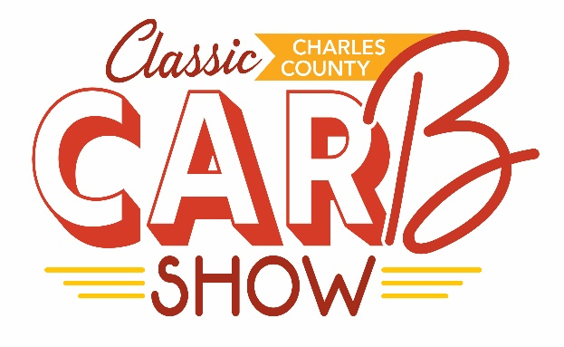
Saturday, May 27, 2023
St. Charles Towne Center- Lot between Macy’s and Dick’s

Car Registration
The Charles County Carb Show is a joint Food Truck Festival and Classic Car show new this year to the county. We will be providing a surprise gift to the first 50 cars that register, so sign up early!
Registration Fee: Waived for the inaugural event year
Car Requirements: All cars are welcome. If you think it’s cool, we think it’s cool

Your Name: __________________________________________________________________________
Car Year: ________ Car Make: ___________________ Car Model: ______________________
Car Color: ____________________________________________________________________________

What do you love about your car?

Will you need a space larger than a parking space? ____ Yes ____ No
Would you be interested in doing a radio or TV appearance? ____ Yes ____ No

____ Morning Show (11:00am - 2:45pm)
____ Afternoon Show (3:00pm – 7:00pm)
____ Both (11:00am – 7:00pm)

On arrival, please check in with a volunteer to receive your designated parking space.
Submit this registration form along with any questions you may have to Rachel Williams.

